8.93: a From symmetry, the center of mass is on the vertical axis, a distance 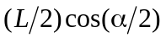from the apex. b) The center of mass is on the (vertical) axis of symmetry, a distance 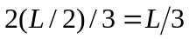 from the center of the bottom of the . c) Using the wire frame as a coordinate system, the coordinates of the center of mass are equal, and each is equal to 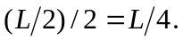 The distance of this point from the corner is 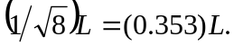This may also be found from consideration of the situation of part 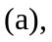with 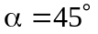 dBy symmetry, the center of mass is in the center of the equilateral triangle, a distance 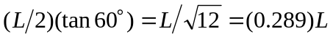above the center of the base.

